**HOMEWORK: PivotTable 101** *(Scroll down for answers)*

**IMPORTANT NOTE:** To complete the homework exercises throughout the course, save a new copy of your IMDb workbook as "***IMDb Movie Database_Homework***" (or something similar), so that you can continue to follow along with the lectures using your original workbook.

In your ***Homework*** workbook, create a new pivot from the IMDb data, and complete the following:

1. Set up a view to show Budget by Title (as rows), with filters for Country (set to *Japan*) and Language (set to *English*). How many Japanese movies in the database were produced in English?
2. Clear the Language filter, set the Country filter to *Denmark*, and pull in Gross Revenue as a second metric. How much gross revenue did "*The Celebration*" generate?
3. Use the "Clear All" command in the PivotTable Analyze options to remove all fields from the table, and create a new view showing Gross Revenue by Country (as rows) and Genre (as columns). How much revenue was generated by Comedy films in Finland?
4. Remove the Country field, move Genre to the row labels, and drag in Rating as secondary row labels. How much revenue was generated by PG-rated Family films? Double click on the cell to see the exact source data populating the value. Which title drove most of the revenue? Once you have your answer, delete the extra worksheet created.
5. Add a fake row of data in the "IMDb Movie Database" tab, beneath the existing rows, and use the Change Data Source option to update the pivot. Create a title-level view and confirm that the new data is included, then delete the entire row in the raw data sheet and refresh the Pivot Table to remove it.

**HOMEWORK: PivotTable Formatting** *(Scroll down for answers)*

In the ***IMDb Movie Database_Homework*** workbook that you created at the end of the first section, complete the following:

1. Show Budget and Gross Revenue by Title, and change the number format to *currency*, with a dollar sign and no decimal places. What was the budget for "A Passage to India"?
2. Remove Budget and Title, and show Gross Revenue by Genre (rows) and Rating (columns). Update the PivotTable options to show "$0" instead of blank values
3. Move Rating to the row labels (beneath Genre), change your table layout to Outline View, and Update your column headers from "*Rating*" to "*Film Rating*", and from "*Sum of Gross Revenue*" to "*Gross Revenue*" (hint: you may need a trailing space)
4. Remove Film Rating from the view, so that you're just viewing Gross Revenue by Genre. Turn Grand Totals off, select the Gross Revenue values, format as *currency* (if they aren't already) and add a Color Scale from Green (high) to Red (low). Which Genre produced the most Gross Revenue?
5. Add a second instance of Gross Revenue, and format the new column with Data Bars. Update the number format (or use the formatting dialog box) to make the text invisible, so that only the bars appear. Which Genre produced the second-highest Gross Revenue total in the sample?

**HOMEWORK: Sorting, Filtering & Grouping** *(Scroll down for answers)*

In the ***IMDb Movie Database_Homework*** workbook that you created at the end of the first section, complete the following:

1. Clear any existing conditional formats, then create a view showing Gross Revenue by Title, with a filter for Year to only include films released in 2005, 2006, 2007 or 2008, then sort the titles descending by Gross Revenue. What's the top-grossing film released during that 4-year sample? (***note:*** *you may need to group your release dates or add a “Year” column to your source data tab*)
2. Add a Label Filter to only include titles that end in "2". How many sequels were released during these years? Which earned the most Gross Revenue?
3. Clear your label filter, and add a Value Filter to only show titles that earned between $1,000,000 and $3,000,000 in Gross Revenue. How many titles fell into this range?
4. Adjust your PivotTable Options to allow multiple filters, then add a label filter to only show movies that start with the letter "M". How many titles are now listed?
5. Add a wildcard to your label filter to only show titles that start with the letter "M" and also contain the letter "s", separated by any number of characters. Which titles are returned?

**HOMEWORK: Calculated Values & Fields** *(Scroll down for answers)*

In the ***IMDb Movie Database_Homework*** workbook that you created at the end of the first section, complete the following:

1. Clear any existing filters, then create a new view to show IMDb Score by Title. What happens when you replace Title with Genre? How can you fix this issue?
2. Update your view to show Average IMDb Score by Genre (primary row labels) and Year (secondary row labels), for 2011-2014. Drag in a second instance of IMDb Score, change the summarization to Average, and show the values as a Rank (large to small) based on the year. Which year in the 4-year sample saw the highest-rated Biography films on average? The lowest?
3. Add in a column for Gross Revenue, and show the values as the % Difference From the previous year. By what percentage did Action movie revenue grow in 2014?
4. Create two new calculated fields named "Profit" (*Gross Revenue - Budget*), and "Profit Margin" (*Profit / Gross Revenue*). Update the view to show just these two new fields by Title, and format Profit as currency and Profit Margin as a percentage with 2 decimal points. Which Title generated the strongest Profit Margin in the entire sample?
5. Create a new calculated field for "Cast + Director Likes" (*Cast FB Likes + Director FB Likes*), and update the view to show Cast + Director Likes by Genre. If you wanted to show this field as an average across titles (*i.e. Cast + Director Likes* ***Per Title***), rather than a sum, how could you accomplish this?

**HOMEWORK: PivotCharts** *(Scroll down for answers)*

In the ***IMDb Movie Database_Homework*** workbook that you created at the end of the first section, complete the following:

1. Create a new view to show # of Titles by Country, excluding the USA, for the entire sample. Name the PivotTable "Titles by Country", then sort the countries descending by title count and use a PivotChart to visualize this view as a Clustered Column Chart.
2. Hide the Field Buttons from the PivotChart, then apply a value filter to only show the top 10 countries by # of Titles. Which country is #2?
3. Change the chart type to a Clustered Bar, and change the PivotTable sorting to ascending by # of Titles.
4. Pull in IMDb Score as a second series, and summarize values by Average. Change your PivotChart type to Combo, with # of Titles as a Clustered Column and IMDb Score as a Line with Markers, on the Secondary Axis. Which of the 10 countries generated the lowest average IMDb scores?
5. Copy the existing pivot and create a second view below the combo chart to show Budget by Genre, with a Top 5 filter applied. Name the table "Budget by Genre", then visualize this view with a Pie chart, with hidden field buttons.
6. Insert a Slicer for Genre, enable multi-select, then connect it to both PivotTables. Create a simple dashboard by hiding the columns of your raw PivotTable views, disabling gridlines, and aligning/formatting the PivotCharts and Slicer as you see fit. Practice adjusting slicer selections to see how the dashboard updates!

**ANSWERS: PivotTable 101**

1. **5**

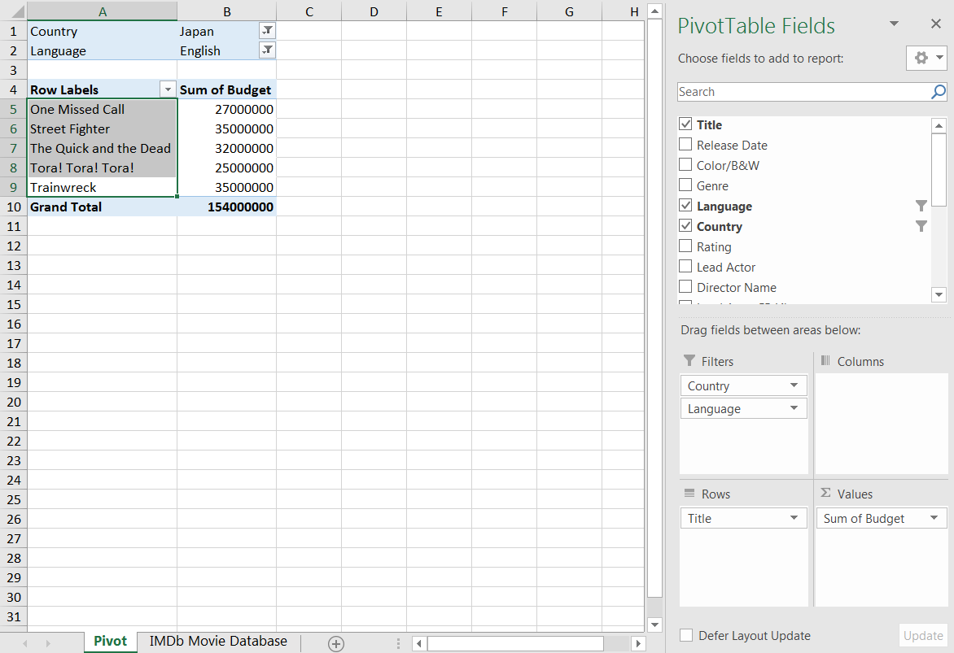

1. **$1,647,780**

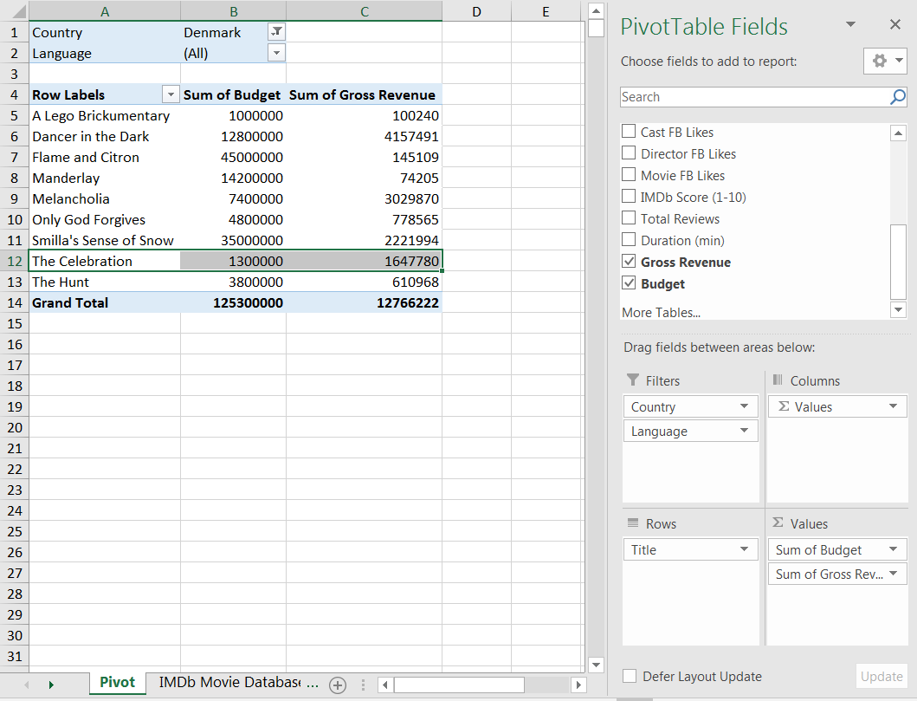

1. **$611,709**

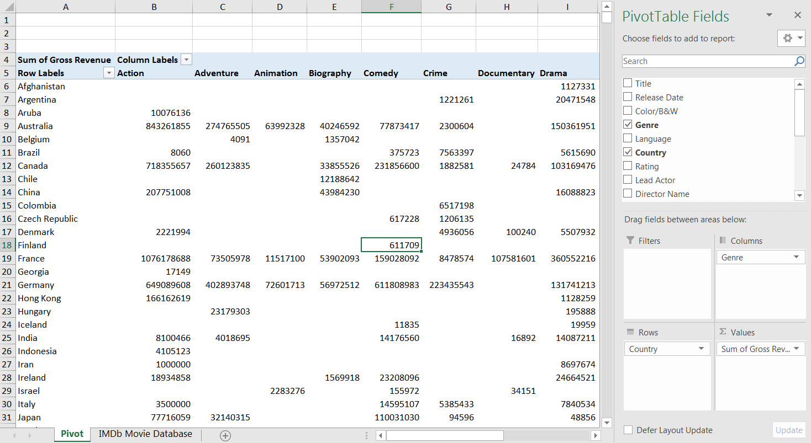

1. **$445,361,439** (*E.T. the Extra-Terrestrial*)

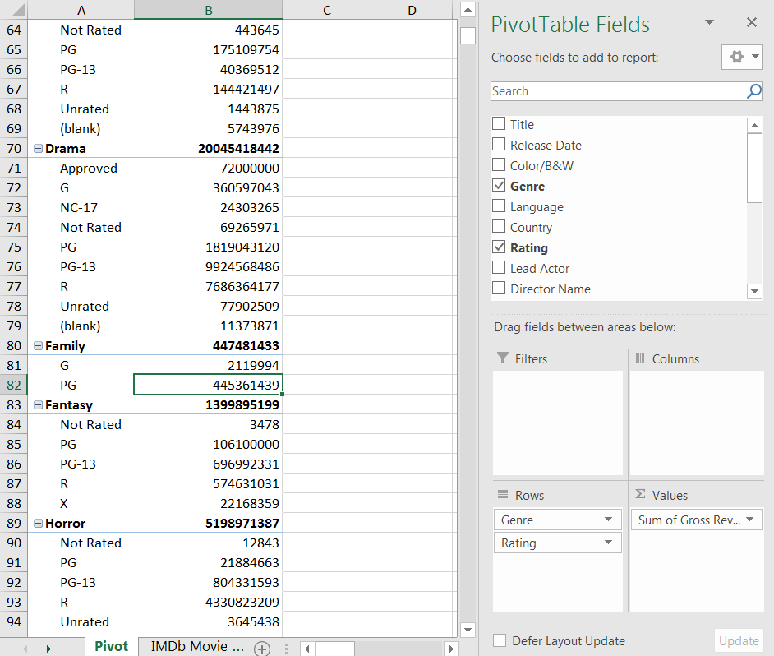

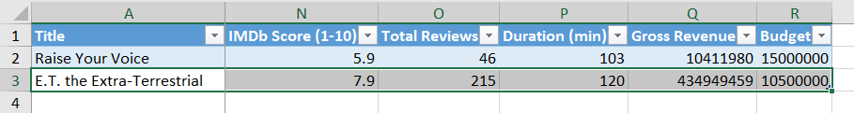

1. **See screenshot:**

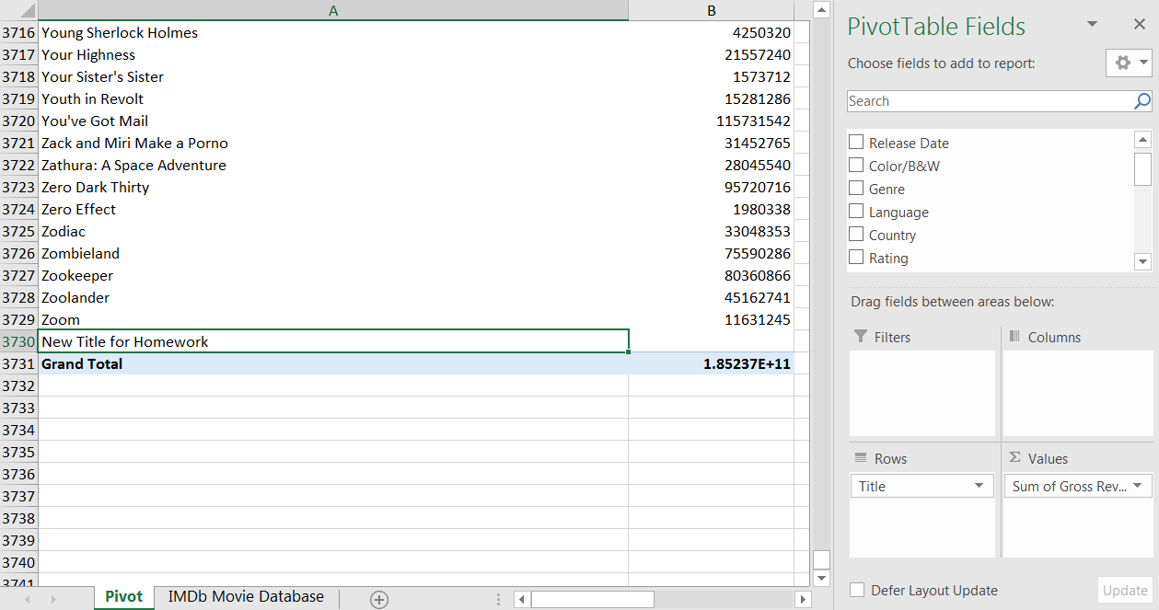

**ANSWERS: PivotTable Formatting**

1. **$16,000,000**

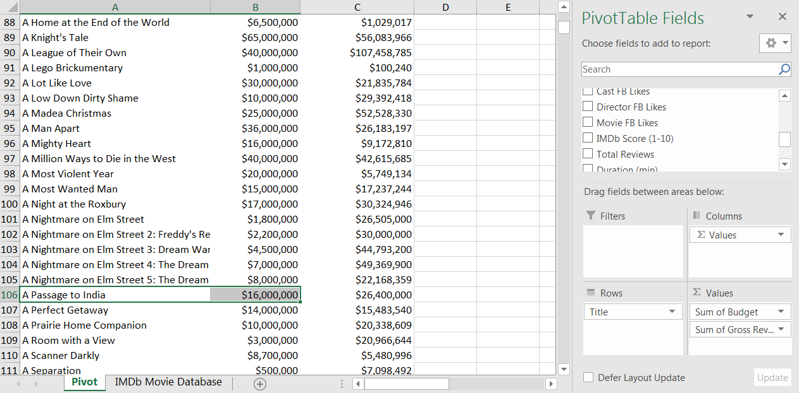

1. **See screenshot:**

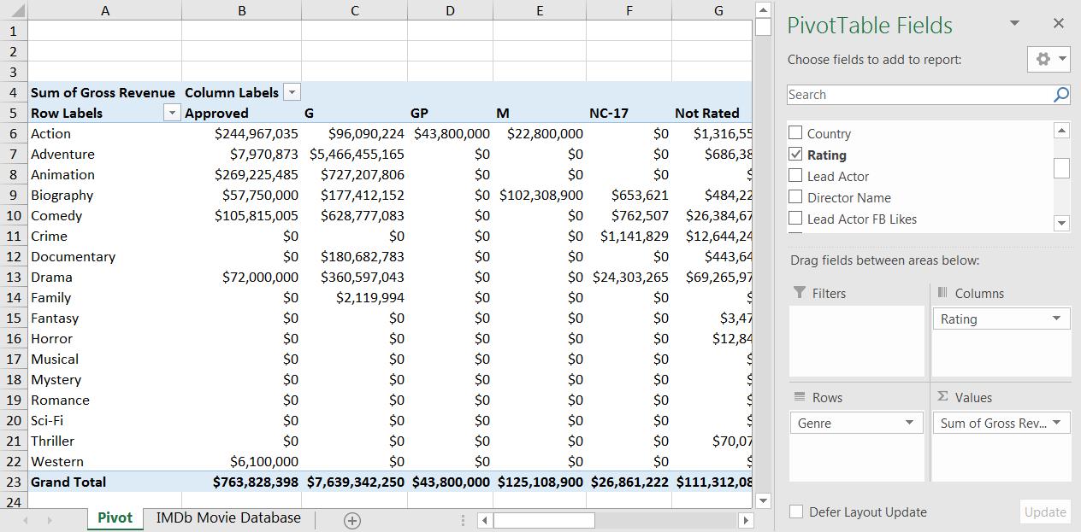

1. **See screenshot:**

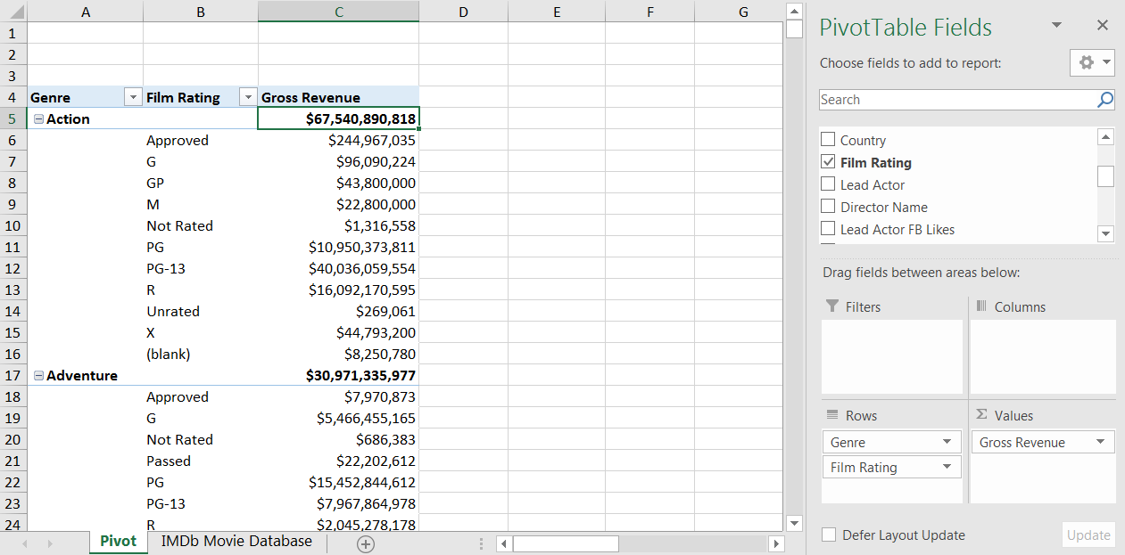

1. **Action**

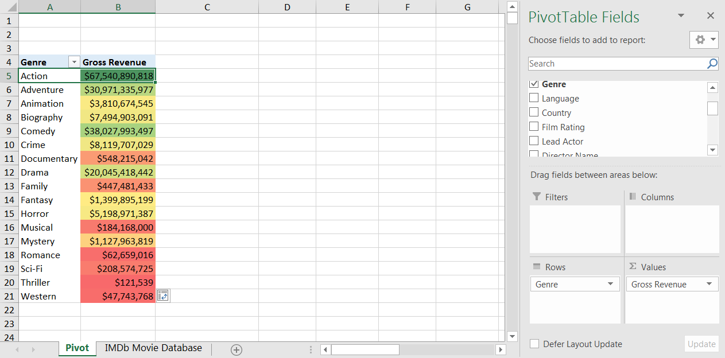

1. **Comedy**

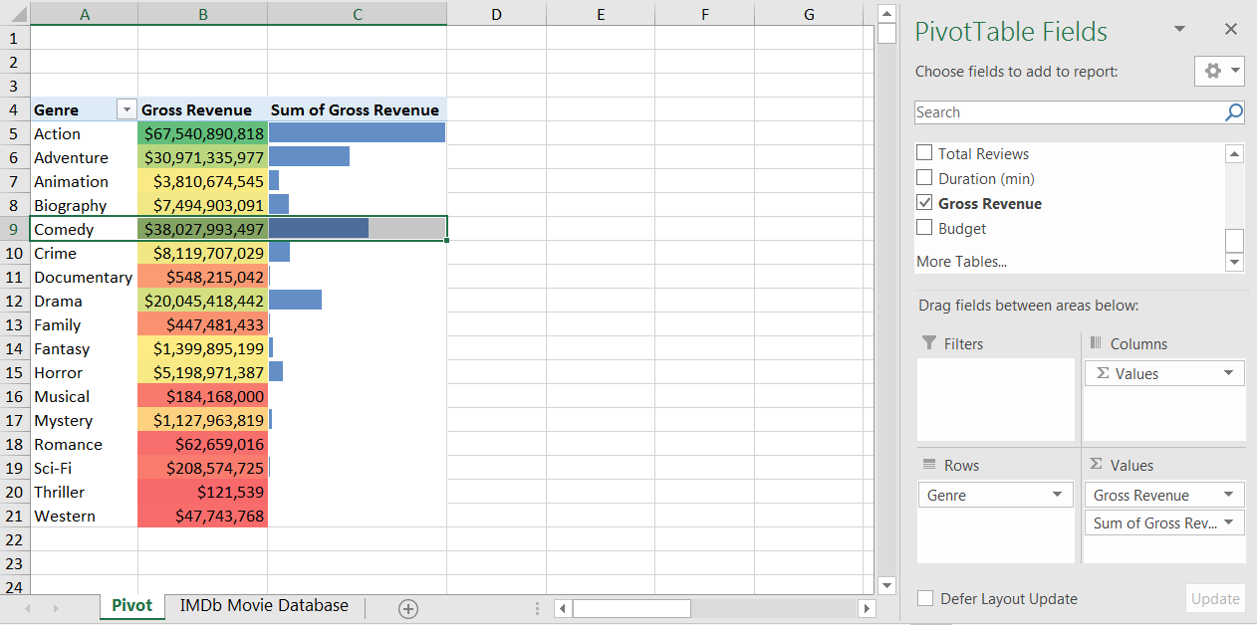

**ANSWERS: Sorting, Filtering & Grouping**

1. **The Dark Knight**

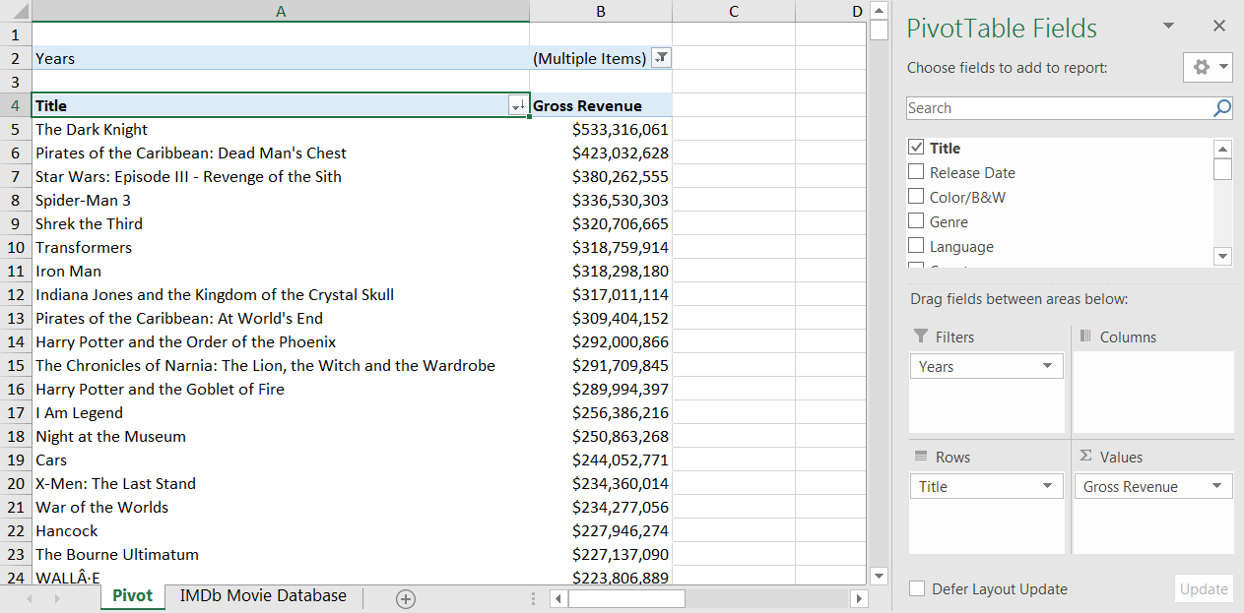

1. **7; Cheaper by the Dozen 2**

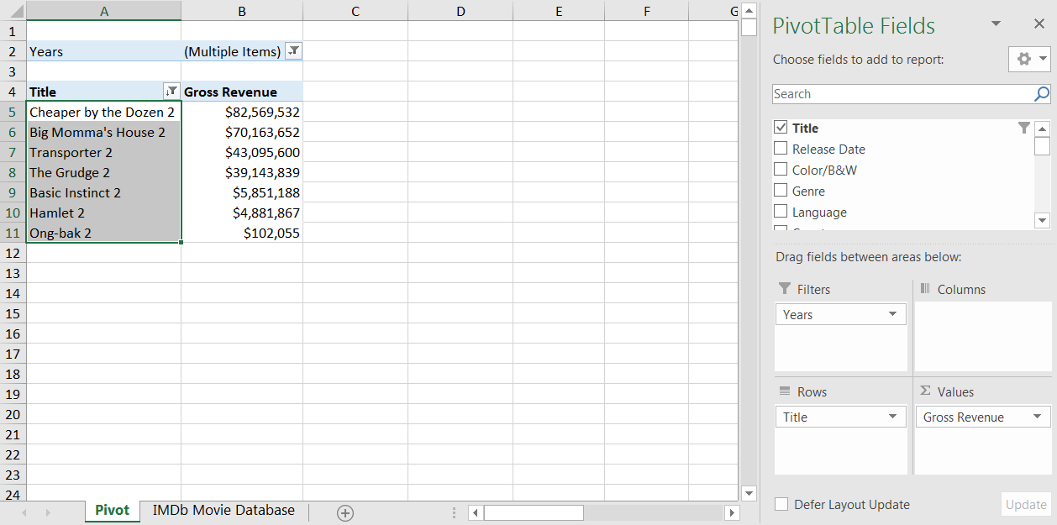

1. **51 titles**

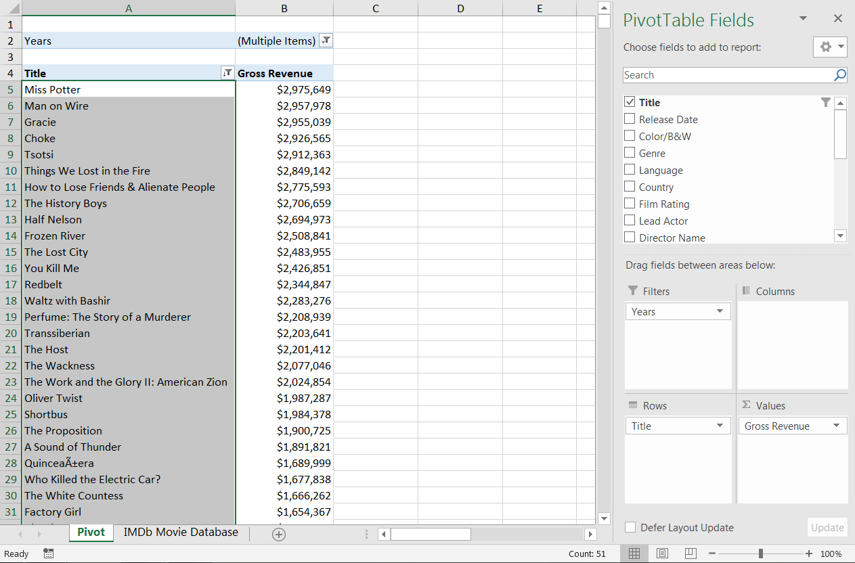

1. **5 titles**

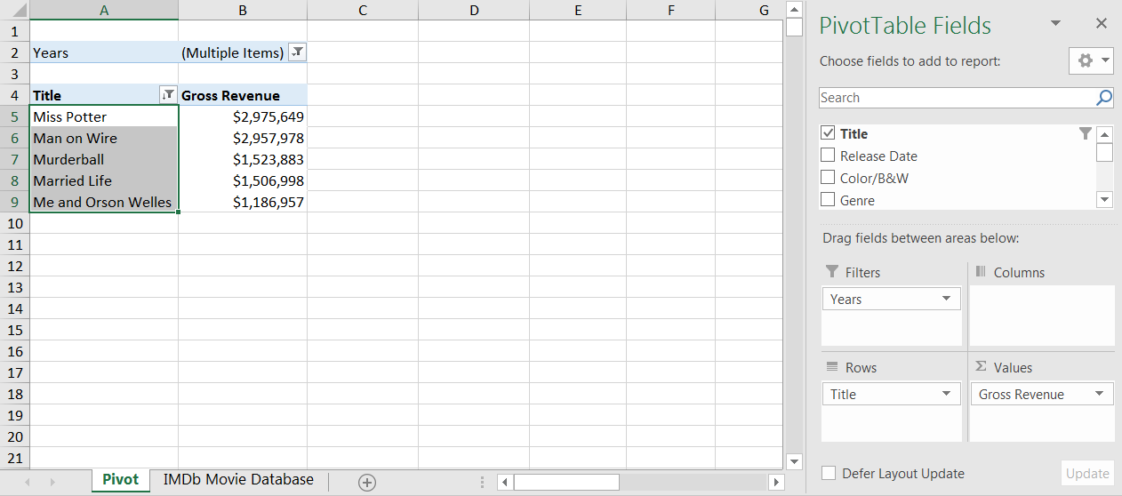

1. **Miss Potter** & **Me and Orson Welles**

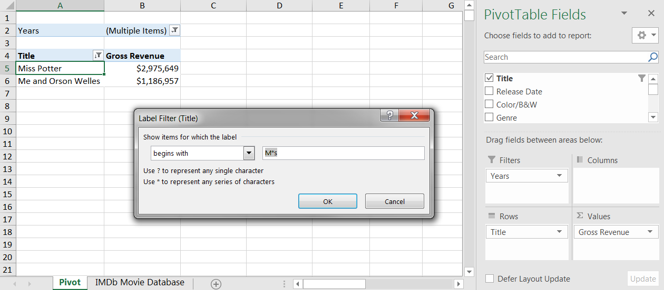

**ANSWERS: Calculated Values & Fields**

1. **IMDb Score defaults to a sum and adds the ratings up across all titles in each Genre. Change the Summarize Values By mode from "Sum" to "Average"**

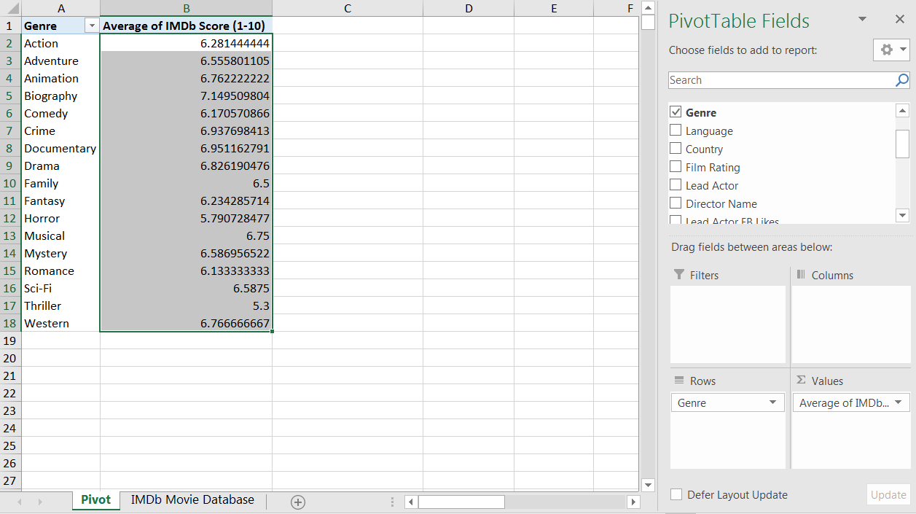

1. **2013** (*7.49 rating*)**. 2011** (*6.81 rating*)

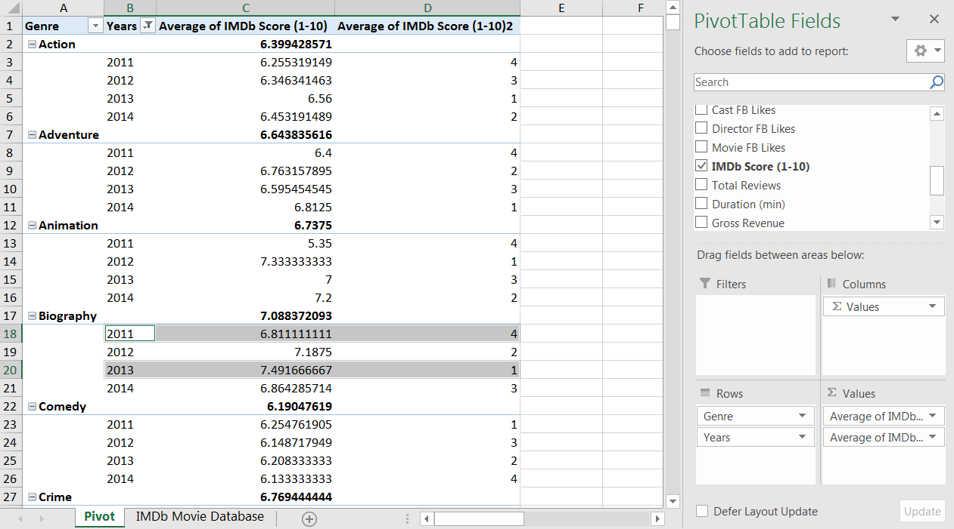

1. **51.7%**

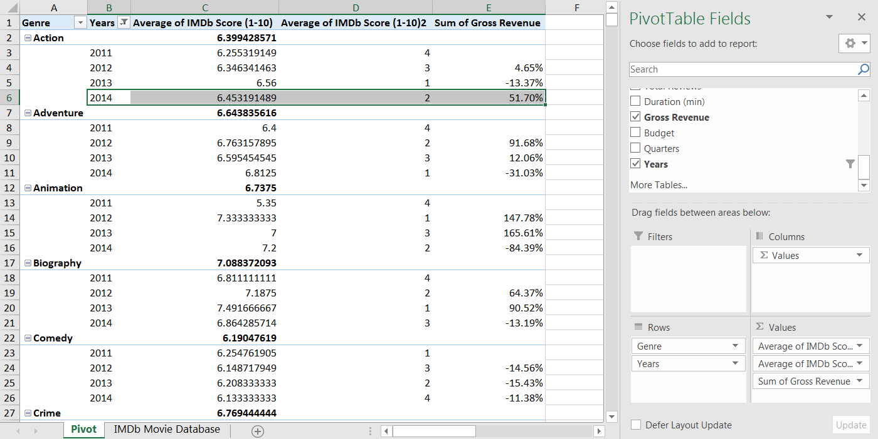

1. **Paranormal Activity**

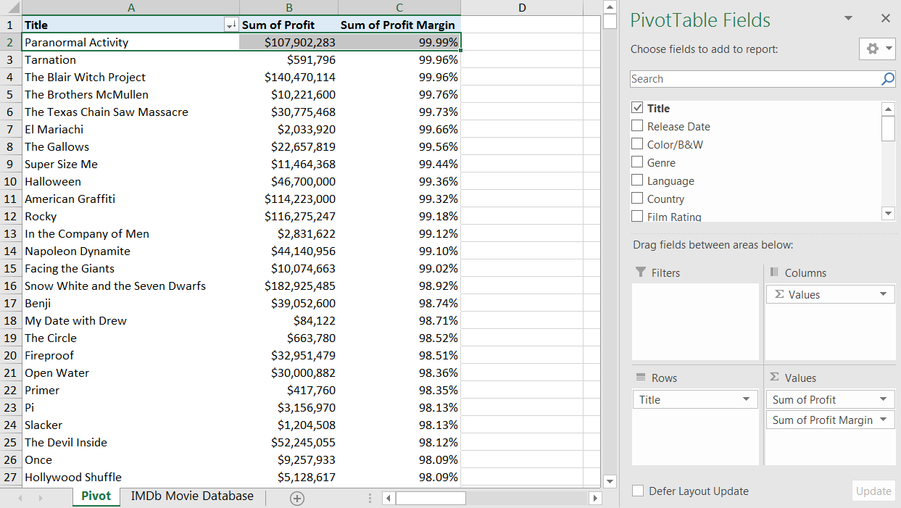

1. **Create a new column in the raw data (i.e. "# of Titles") equal to 1 for each row, then update your calculated field to: (Cast FB Likes + Director FB Likes) / # of Titles**

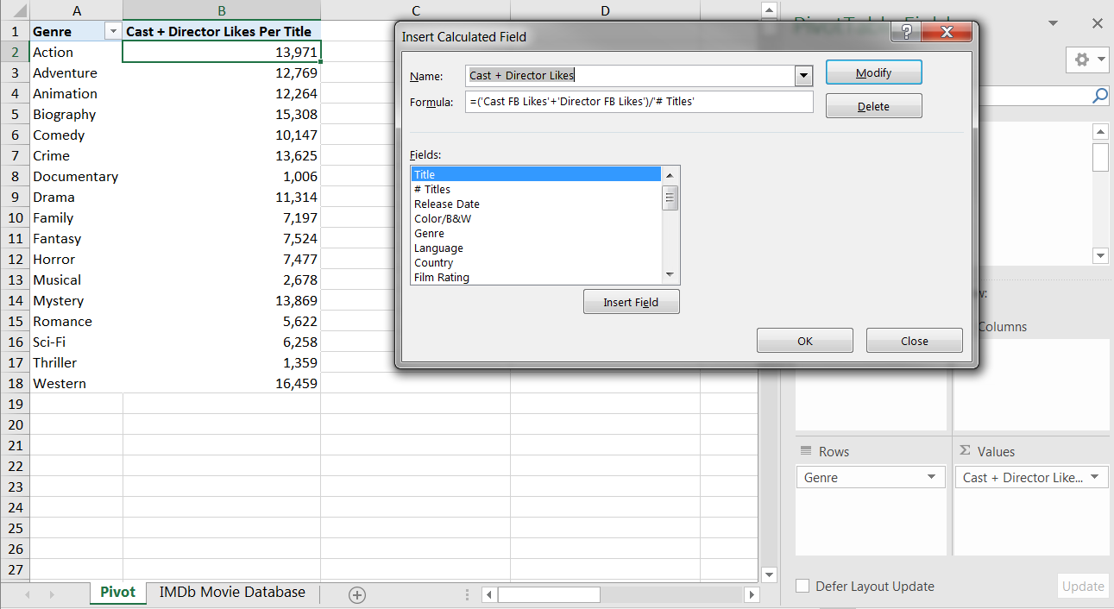

**ANSWERS: PivotCharts**

1. **See screenshot:**

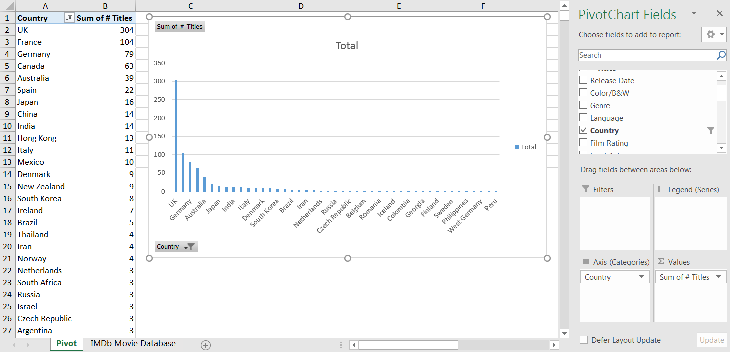

1. **France**

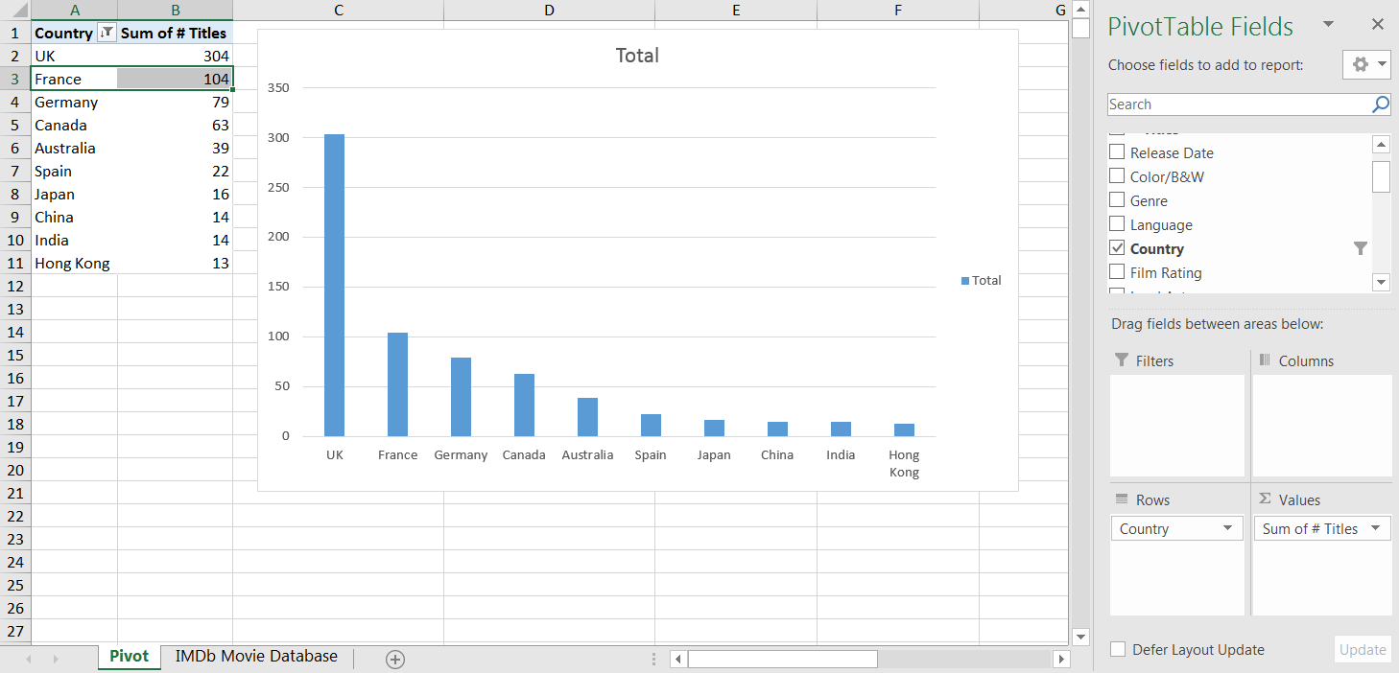

1. **See screenshot:**

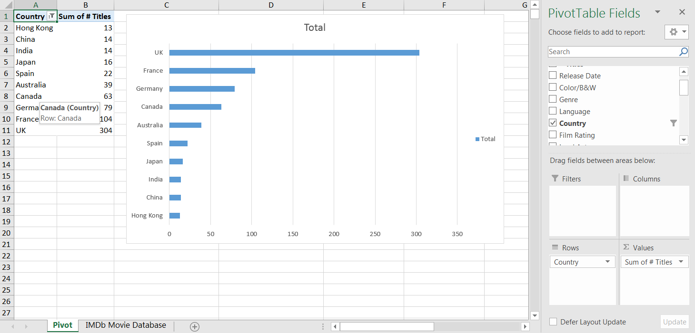

1. **Canada**

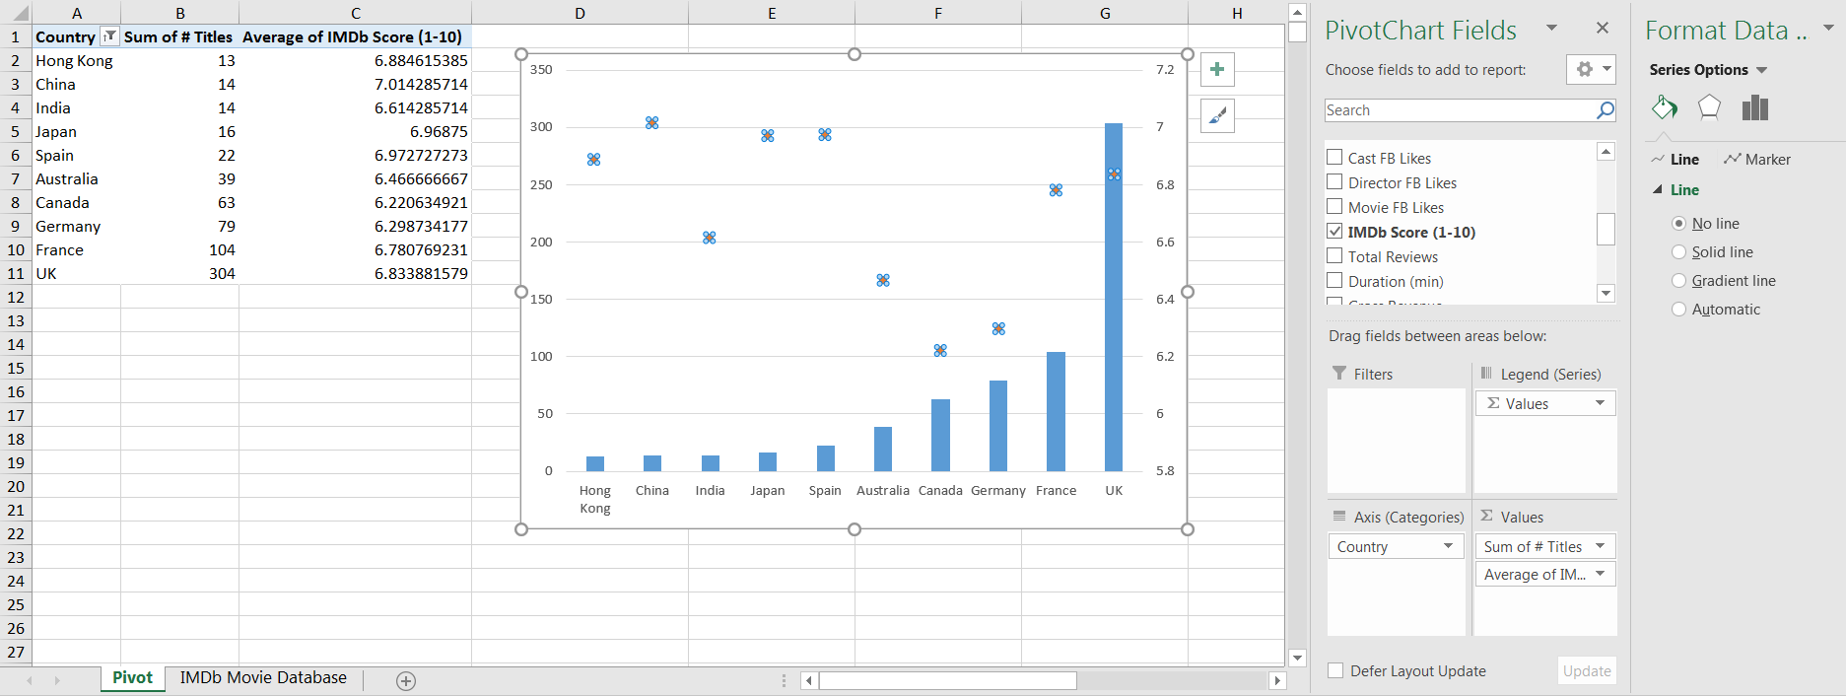

1. **See screenshot:**

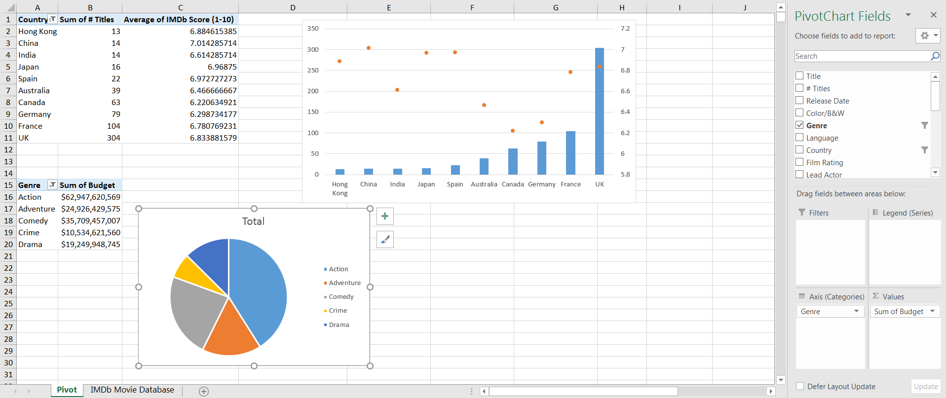

1. **See screenshots:**

